**Section One: Multiple-choice (16 marks)**

This section has **8** questions. Answer **all** questions on the separate Multiple-choice Answer Sheet provided.

1. Two solutions of equal concentration, A and B, have a pH of 3 and 6 respectively. Which of the following statements about the solutions is/are true?
2. They will show the same colour in universal indicator.
3. The concentration of H+ is higher in B than it is in A.
4. B is a weaker acid than A.
5. (ii) only
6. (iii) only
7. (i) and (ii) only
8. (i), and (iii) only

2. The following questions relate to this equation:

HPO42-(aq) + H2O(l)  H2PO4-(aq) + OH-(aq)

Which of the following statements is **false?**

1. The HPO42- behaves as a base.
2. The water is acting as an acid..
3. The H2PO4- is acting as an acid.

d) The hydroxide ion is acting as a conjugate acid

3. Which of the following groups is ranked in order of increasing molecular polarity?

a) CH2Cl2, CH2F2, CH2I2

b) H2Te, H2Se, H2S

c) HBr, HF, HI

d) CH3F, CH4, CF4

4. Which one of the following could be true in an aqueous solution of sodium hydroxide?

1. [H+] = (OH-]
2. pH = –log10 [OH-]
3. pH= 1.2
4. pH = 12.8

5. Which one of the following is the change in units of pH which occurs when 10.0mL of a 1.0 M solution of a strong monoprotic acid are made up to 1.0 L with water?

1. 1
2. 2
3. 3
4. 5

6. 10.0 mL of water is added to one litre (1L) of pure ethanoic acid. The resulting

solution is:

1. A dilute solution of a strong acid
2. A concentrated solution of a strong acid
3. A dilute solution of a weak acid
4. A concentrated solution of a weak acid

7. Reverse phase high pressure liquid chromatography uses a non-polar stationary phase and a polar mobile phase.

Which of the following would have the longest retention time on the reverse phase column?

B

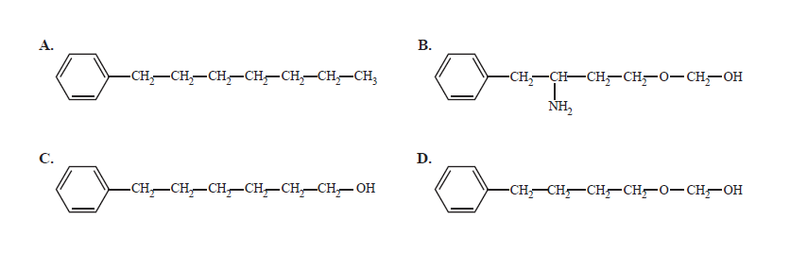

8. The diagram below shows the chromatogram for large straight chain alkanes (hydrocarbons containing only carbons and hydrogens).

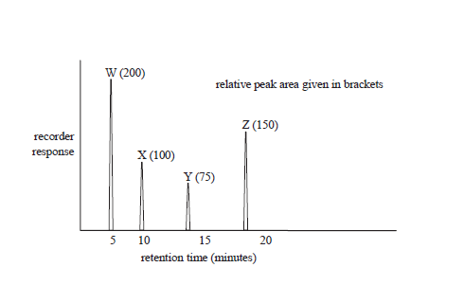

The following statements refer to the chromatogram.

I The boiling points are arranged in increasing boiling point W> X>Y> Z.

II The retention times will remain the same if the temperature at which the chromatogram is recorded is increased, all other conditions remaining constant.

III. Hydrogen gas could have been used as a carrier gas to obtain this chromatogram.

Which of the above statements are true?

a) I only

b) I and II only

c)I and III only

d) II and III only

**END OF SECTION ONE**

Section 2: Extended Answers (40 MARKS)

Question 1

a) Using an equation, define pH: (1)

……………………………pH = -log [H+]…………………………………………...

b) 100.0 L of a 0.010 mol L-1 solution of hydrochloric acid is concentrated by careful evaporation of the water to a final volume of 10.0 L. Calculate the final pH of the solution. (2)

n = c*V

n =0.010 * 100 = 1.0 mol

c2 = 1.0 / 10 L = 0.10 mol L-1

pH = -log [0.10] = 1

pH = 1.0

Write balanced equations (ionic where appropriate) to represent the following reactions: (9)

a)Lead (II) oxide solid and dilute nitric acid are mixed

1. Lead (II) oxide solid and dilute nitric acid are mixed

Observation**: black solid dissolves to form colourless solution .**

Equation: **PbO + 2 H+ 🡪 Pb2+ + H2O**

1. A piece of magnesium carbonate is reacted with dilute hydrochloric acid.

Observation: **white solid dissolves in colourless solution to form a**

**colourless/odourless gas**

**MgCO3 + 2 H+ 🡪 Mg2+ + H2O + CO2**

1. Some small pieces of calcium are added to dilute phosphoric acid
2. Observation: **white solid dissolves in colourless soltuion, form cl/cl gas**

Equation: **3 Ca + 2 H3PO4 🡪 Ca3(PO4)2 + 3 H2**

**Question 3** (6)

For each species listed in the table below show the bond diagram showing the shape or molecular geometry. No marks will be given for the electron dot diagram but may aid in your structural diagram. For each identify the species as polar or non-polar.

|  |  |  |  |
| --- | --- | --- | --- |
| **Species** | **Electron dot diagram** | **Structure Diagram (1 mark each)** | **Polar or Non-polar (1 mark each)** |
| Phosphate ion  (PO43-) |  |  | Non-polar |
| Phosphine  (PH3) |  |  | polar |
| Thionyl chloride  SOCl2 |  |  | polar |

Question 4 (4 marks)

For each of the solid substances state the two most important types of bonding acting within that substance. The first one has been done for you.

|  |  |
| --- | --- |
| **Substance** | **Two strongest bonding forces** |
| Oxygen (O2) | Covalent: dispersion |
| Hydrogen chloride | *Covalent, dipole-dipole* |
| Sodium hydroxide | *Ionic, covalent* |
| Water | *Covalent, hydrogen bonding* |
| Graphite | *Covalent network, dispersion* |

Question 5 (4 marks)

With reference to strength and types of intermolecular forces account for the difference in the boiling points of the following pairs of compounds.

a. methanol (65 ⁰C) and methane, CH4 (-162 ⁰C) (2 marks)

The large difference in boiling points must be due to the presence of hydrogen bonding in methanol, which is strong intermolecular force, its slightly higher dispersion forces would not cause this significant of a change.

b. Methanol and octane (C8H18, 126 ⁰C) (2 marks)

As dispersion forces increase as the size (number of electrons) of a molecule increases. As octane is significantly larger than methanol. This explains the higher bp then methanol, despite the hydrogen bonding that occurs in methanol

**Question 6**

Consider the following situation as and suggest the best chromatographic technique. Briefly state a reason for your choice. (4 marks)

a. A technique suitable for analysing minute samples of volatile fuel residues extracted from the burnt remains at a suspected arson scene

GC – volatile, minute

b. A pharmacological analysis of a mixture of a very high molar mass proteins and polypeptides present in biological fluids.

HPLC – fluids, small amounts, not volatile

c. Analysis of air sample for pollutants like sulphur dioxide , nitrogen oxides and various hydrocarbon compounds.

GC- already a gas, small amounts

d. Analysis of the sugar content of a fruit juice.

TLC- not as quantitative but suitable inexpensive analysis

**Question 7**

A 2.89 g sample of sandstone, containing only calcium carbonate and silicon dioxide, is analysed by reacting it with hydrochloric acid.

A volume of 10.7 ml of 2.50 mol L-1 hydrochloric acid solution is required for complete reaction.

1. Write an ionic equation for the reaction (1)
2. Calculate the mass of calcium carbonate that is used up in the reaction. (3)

**a)**

**CaCO3 + 2 H+ 🡪 Ca2+ + CO2 + H2O (1)**

**b)**

**nHCl = 2.50 x 0.0107 = 0.02675 mol HCl (1)**

**nCaCO3 = ½ x nHCl (1)**

**m CaCO3 = 0.013375 x 100.09 = 1.3387 (1)**